Indra Mursid, LPC
OLATHE SOUTH’S CONTRACT CLINICIAN 2022-2023

WHO: Olathe South is working with Resolve Counseling & Wellness this year to help provide mental health support to our students. This year we are teaming up with contract clinician Indra Mursid, Licensed Professional Counselor. Indra earned her Bachelors of Arts in 2018 and her Masters of Science in Counseling Psychology from Avila University in 2021.
HOURS: Will be available to meet with students at Olathe South on Wednesdays all day, and every Thursday from 8 a.m. until 11 a.m.
HOW: If you would like additional information on referring your student for this therapeutic support, please contact your students OS counselor, social worker or administrator. All referrals are confidential.

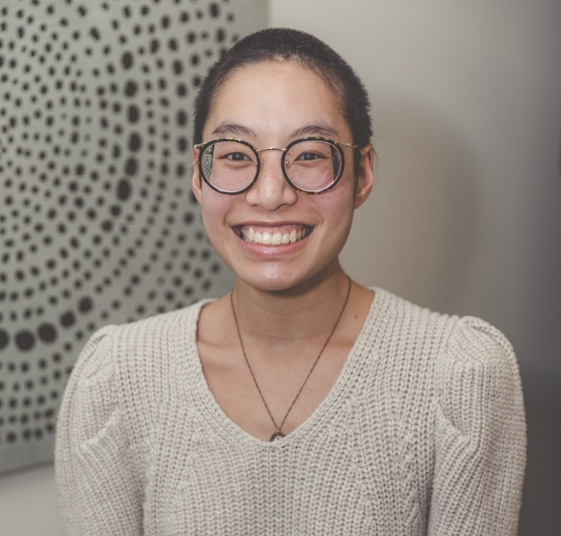
Indra specializes in anxiety, depression, life transitions, and navigating identity, sexuality, and career paths. She has previous experience with working for non-profit organizations and higher education, including community colleges. Indra is an 2SLGBTWIA+ affirming therapist and works from a collaborative framework that focuses on the clients wants and needs. The goal is to cultivate a warm, inviting, and safe space students to expand, process, heal, identify, and explore. She is here to support and empower you.

